Reflection: E-Portfolio Maria Isaac

Composition in Music Education MUED3603 – Assessment Task 1

The section on Carl Orff time signatures (with a note instead of a number to represent the basic unit) states that these signatures eliminate the need for 'complex' time signatures.
Shouldn't that word be 'compound'? Orff signatures enable rewriting compound signatures like 6/8 with 2/dotted-quarter. – Wikipedia.

I believe Orff is a method in which teachers can succeed in teaching music. The perfect learning environment is created for short pieces and I think that any song can be learnt using the Orff method.

“A well-conducted lesson is not a burden, but a recreation: the source of joy and cheer.” - Zoltán Kodály.

Orff is closely linked to methods of Dalcrose, Suzuki and many more, which I find achieve ease in learning music for a range of students. They allow students to discover music in a more practical way - ‘play’, through listening, imitating, and watching for patterns and shapes. This guides and propels students into their zone of proximal development where they may grow as musicians. It is also a well-structured method of teaching a section of a song for stage 3 and can be applied to learning other styles.

‘Less is more: More or less’ – Minimalism.

For my composition, I used Steve Reich’s commissioned piece performed by Pat Metheny in 1987 called “Electric Counterpoint – Mov. III Fast”. This piece is squarely one of using loops and phasing music, introducing phrases slowly and creating a timely piece via extensive overdubbing. Featuring in the video game “Civilization V” it is a ‘great work of music’. Steve Reich uses rhythmic shifting among other things to achieve the style as in a round or canon.

Steve Reich is a composer of whom I first had interest in when I heard his City Life piece. The greatly deep concept behind it was something of which I’ve always had in mind to artistically portray and it was great to watch the video produced and here his intricate compilation of sounds.

I researched to find some articles on arranging minimalist music into an Orff formula and found not that many. I researched Steve Reich and his electric counterpoint and found some information on its musical characteristics, creation and its performance, with the use of technology and…

‘extensive overdubbing’ – Electric Counterpoint.

Steve I believe composed this with quite the technological mind, almost ‘MARS’ like in a sense that this piece may be used to depict a movie out of space or circulating things. He in particular ‘fades’ the music in and out, a very warp-like effect and the creation of a hollow echo.

It was titled ‘electric’, something of which I could work with (my Roland Rc-300), it was a counterpoint, great for Orff style arrangements, and it had this bemusingly attractive bass rhythm where two bass guitars would play an ostinato sounding very close in rhythm but creating the effect of one. This would soon become the bordun bass line in my arrangement and I could hear from this section, the potential of it being arranged as an Orff piece for an ensemble large or small, so I began working on it.

First listening, I began clapping rhythms that I felt best embodied the music and wrote some notes down as possible percussion lines transferred from body percussion.

I decided to arrange and simplify the idea from Steve’s first guitar melodies played in the piece, then one from the guitar chords section and one of the bass guitars. Towards the end, I also added a basic melody of my own that could be sung to highlight the piece. I then practiced at university using mallets to display mirrored gestures to teach the class. Then I practiced all sections by looping it on my Rc-300 to deliver a live performance of it before teaching it.

My arrangement was created with the Orff principles firmly in mind while trying to create something different and innovative. Knowing the ranges that are possible on xylophones (assigning melody for soprano range and bordun for bass xylophone) and the movements involved, I needed to omit a couple of lower notes also to help stage 3 students with the timing of mallets, so I modified the lines trying to maintain their original sound and ‘overdubbing’ effect. The score I set up in Sibelius to make sure that the format was correct, system lines and labels were correct, the bass xylophone was at the end, and the subsequent higher melodies at the top with voice and soprano xylophone. It incorporates the percussive elements Frazee addresses, Snap, Clap, Patsch and Stomp, the use of voice (singing lyrics or solfege) and several facets of the Orff formula such as the time signature and L R indications.
For the soprano xylophone’s rhythm, I created a demonstration using mallets on floor and thighs to assist and clarify the movement and space of the notes on the xylophone.
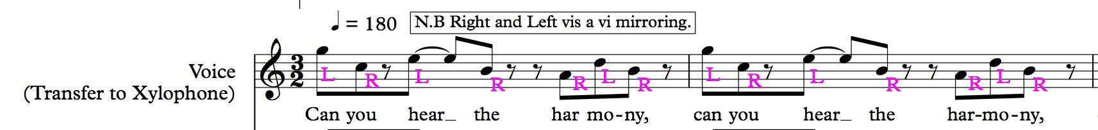

you

Top view of thighs and mallet-ing.
Can

hear
har-
mo-

ny
the

Bass xylophone rhythm 1, even, quick, short. Gestures of proximity were imitated.
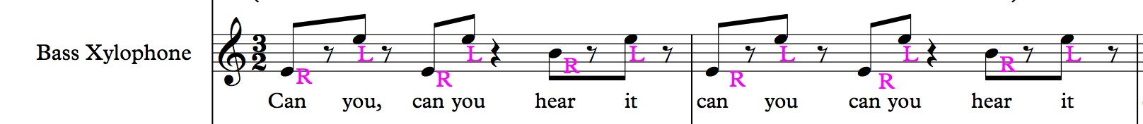

Bass xylophone rhythm 2, space, even, quick. Gestures of proximity were imitated.
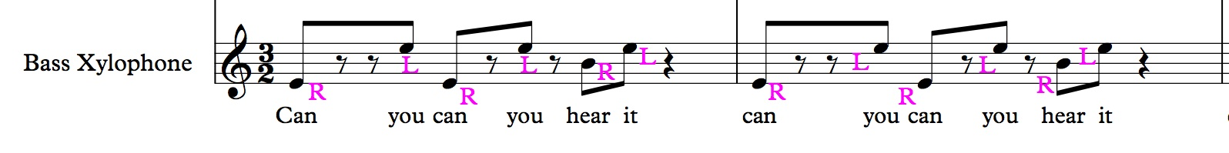

The tom toms rhythm playing quavers on the last beat and the first beat of the next bar, I feel is a jazzy pop feature I wanted to include.
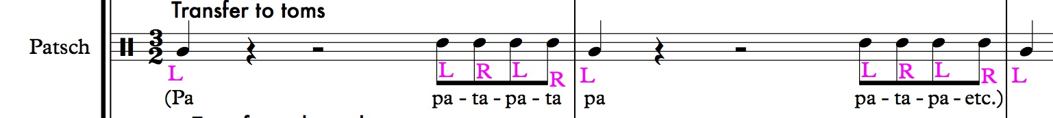

The egg shaker rhythm supports the rhythm of the soprano xylophone.
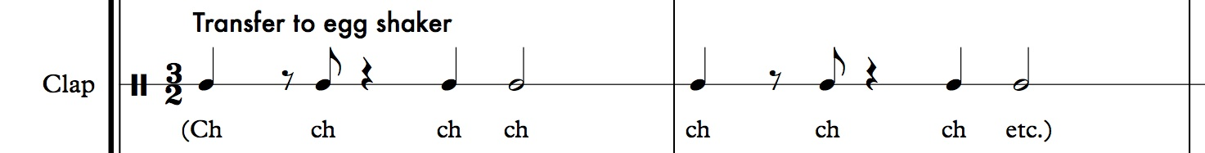

(Please see full Score for the complete version)

Essentially what happens is one melodic rhythm or idea is played then rhythmically displaced to create an effect or similar to the original via augmentation or diminution and more, then a second or third idea is created and the same happens also, creating many possible lines and a soundscape.

The next idea I had was to have students play the repeated idea in the one key for four bars and then play the idea one step (note) higher. For example four bars from the note E in the bass then four bars from the note F keeping the ostinato shape and pattern the same, similar to the overall 3-4 minute effect in ‘electric counterpoint’ but in a shorter experience. For its performance, to end off the piece by dramatically sounding ‘faster’, students may then play one bar of each, E, F, E, F, then create a drone on the note E for one bar to end off, similar to that in ‘Electric Counterpoint’.

Both of these I could achieve performing on a looping station so the Orff concept can strongly be used in a new way using technology.

I often used my iPad and the ‘Awesome Xylophone’ app to make sure of the range, movement of the mallets and its playability overall.
“The deeper connection with Orff however is recognising that electronic music and instruments could have cultural values and knowledge embedded in their design and practice in same way as what has come to be known as the Orff method” – Orff and Keetman. So, ‘whilst the Orff method focused on making sense of Western art music through experience electronic environments potentially can make sense of the world of multi media that pervades our lives.’

For example in a year 8 setting, students can learn about the evolution of 20th Century Music and its impact. They can compose and perform minimalist pieces, and use sequencing and audio manipulation software to produce original soundscapes. The small groups or whole class will then perform the minimalist pieces. Students can compare the wide variety of experimental music and its influence. Students will also be using technology such as audio recording and manipulation skills in programs and software or using electronic instruments.

References

- Adler, S. (2011, August 28). Wright-Stuff Music » Orff Orchestration & Notation. WrightStuff Music. Retrieved March 25, 2014, from http://wrightstuffmusic.com/in-the-classroom/orff-orchestration-notation

- Alaton, S. (1987, Dec 17). Music world comes to accept the minimalism of steve reich. The Globe and Mail. Retrieved from http://ezproxy.library.usyd.edu.au/login?url=http://search.proquest.com/docview/386063233?accountid=14757

- Ardrey, C. M. (1999). Middle school general music: Kodaly, dalcroze, orff and the developmental needs of adolescents. (Order No. 9938640, Temple University). ProQuest Dissertations and Theses. Retrieved from http://ezproxy.library.usyd.edu.au/login?url=http://search.proquest.com/docview/304534809?accountid=14757. (304534809).

- Ballantyne, J., & Bartleet, B.-L. (Eds.). (2010). Navigating music and sound education. Newcastle: Cambridge Scholars.

- Beazley, K. (2012). "My, that's an Orff-ly critical music lesson"... Examining the connection between an Orff approach to music education and the principals of Critical Pedagogy. Musicworks: Journal of the Australian Council of Orff Schulwerk, 17(1), 7-14. Retrieved from http://search.informit.com.au.ezproxy2.library.usyd.edu.au/documentSummary;dn=688049338885303;res=IELHSS

- Bolden, B. (2007). Music makers: Composing matters - part four: Consequences of composing. Canadian Music Educator, 48(4), 45-48. Retrieved from http://ezproxy.library.usyd.edu.au/login?url=http://search.proquest.com/docview/1029448?accountid=14757

- BOSS LOOP CONTEST 2011 - "Jugutaka" - Renato Martins. (2011, October 3). YouTube. Retrieved March 25, 2014, from http://www.youtube.com/watch?v=VeV4teOLgc8
- Campbell, P.S. (2005). Cultural Diversity in Music Education. Bowen Hills, Qld: Australian Academic Press. Retrieved from http://search.informit.com.au.ezproxy2.library.usyd.edu.au/documentSummary;dn=262252791482196;res=IELHSS.

- Clements, A. (2008, Nov 07). Film & music: Classical reviews: Reich: Electric counterpoint; kraftwerk: Tour de france; etc: Powerplant/Elysian quartet: 3/5 (signum) pounds 11.99. The Guardian. Retrieved from http://ezproxy.library.usyd.edu.au/login?url=http://search.proquest.com/docview/244331478?accountid=14757

- De Frece, R. (2010). Planning for Success: Optimizing Your Teaching. General Music Today, 24(1), 32–40. doi:10.1177/1048371310368485

-Dillon, S. & Hirche, K. (2009) “Switched on Orff: navigating technological contexts and experience design in music education and sound education. Cambridge Scholars Publishing, Newcastle upon Tyne. (In Press)

- Electric Counter Point Steve Reich. (n.d.). YouTube. Retrieved March 25, 2014, from http://www.youtube.com/watch?v=hhhFl0Ab2lo

- Goodkin, D. (2001). Orff-Schulwerk in the New Millennium. Music Educators Journal, 88(3), 17-23. Retrieved from http://www.jstor.org/stable/3399753

- Foley, A. D. (2013). Children's aural and kinesthetic understanding of rhythm: Developing an instructional model. (Order No. 3560981, University of Rochester). Available from ProQuest Dissertations and Theses database. (Record No. 1362256770). Retrieved from http://ezproxy.library.usyd.edu.au/login?url=http://search.proquest.com/docview/1362256770?accountid=14757

- How Can We Nurture Creativity In Educational Contexts?. (2011, July 25). YouTube. Retrieved March 25, 2014, from http://www.youtube.com/watch?v=FB7vZyDgnC4

- Ioffe, Y., Charters, L., Merkley, K., Pickthall, N., & Stacey, J. (2007). Imagination...à la orff. The Canadian Music Educator, 48(4), 48-52. Retrieved from http://ezproxy.library.usyd.edu.au/login?url=http://search.proquest.com/docview/231064061?accountid=14757

- Kim, R. Y. (1999). From new york to vermont: Conversation with steve reich. Current Musicology, (67), 345-366. Retrieved from http://ezproxy.library.usyd.edu.au/login?url=http://search.proquest.com/docview/224865925?accountid=14757

- Koops, L. H., & Taggart, C. C. (2011). Learning Through Play: Extending an Early Childhood Music Education Approach to Undergraduate and Graduate Music Education. Journal of Music Teacher Education, 20(2), 55–66. doi:10.1177/1057083710373578

- Laycock, J. (2005). Musical Vernaculars as a Starting Point: Inspiration for Creative Composition in Formal and Informal Educational Environments. In: Campbell, Patricia Shehan (Editor). Cultural Diversity in Music Education. Bowen Hills, Qld: Australian Academic Press, 49-56. Retrieved from http://search.informit.com.au.ezproxy2.library.usyd.edu.au/documentSummary;dn=386926002170812;res=IELHSS EISBN: 9781875378869.

- Lyne, J. K. (1998). A synthesis of orff, kodály, suzuki, and rolland: Improvisation in the beginning string class. American String Teacher, 48(1), 79-81. Retrieved from http://ezproxy.library.usyd.edu.au/login?url=http://search.proquest.com/docview/965028?accountid=14757

- Orff, C. & Keetman, G. (1952). Music for Children, vol.1 to V, V vols., Schott and Co., Longon.

- Peters, B. (2011). The Orff Approach and Canadian Music Education Curriculum for the 21st Century. The Canadian Music Educator. Canadian Music Educators Association University of Alberta. Retrieved from http://www.highbeam.com/doc/1P3-2571065881.html

- Reyher, A. (2014). Idea Bank: Popular Culture and Video Games as Tools for Music Learning. Music Educators Journal, 100(3), 16–17. doi:10.1177/0027432113519067

- Steen, A. (1992). Exploring Orff: a teacher’s guide. New York: Schott Music Corp.

- Steve Reich - Electric Counterpoint, III. Fast (with sheet music). (2013, August 28). YouTube. Retrieved March 25, 2014, from http://www.youtube.com/watch?v=_TKVpUSWCug

- Taylor, D. M. (2012). Orff Ensembles: Benefits, Challenges, and Solutions. General Music Today, 25(3), 31–35.

- The Orff Echo Seeks Submissions: Orff Schulwerk and 21st Century Skills. (2014). American OrffSchulwerk Association. Retrieved March 25, 2014, from http://aosa.org/the-orff-echo-seeks-submissions-orff-schulwerk-and-21st-century-skills/

- Watson, S. (2011). Using Technology to Unlock Musical Creativity. New York: Oxford University Press USA.

- Webster, D. (1986, January 09). STEVE REICH: TAMING THE AVANT-GARDE. Philadelphia Inquirer. Retrieved from http://ezproxy.library.usyd.edu.au/login?url=http://search.proquest.com/docview/293852108?accountid=14757

